**A Comparative Study of Influencing Factors in Urban and Rural Elderly Care Services in China: A Bibliometric Thematic Evolution Analysis**

## Introduction

Aging societies like Japan, Sweden, and Norway have addressed elderly care challenges through integrated care and decentralized governance. In contrast, China’s rapid urbanization and urban-rural disparities, alongside its aging population of over 260 million people aged 60 and above (Eggleston, 2020), present unique obstacles. These disparities in economic development, infrastructure, and cultural practices hinder equitable care provision (Sun et al., 2019). Urban regions often benefit from substantial government subsidies and advanced healthcare systems, enabling the provision of diverse elderly care services, including institutional, community-based, and innovative care (Han et al., 2020); these services are generally our cognate ones again. However, they can be intended to meet any requirements the elderly residents may have, from simple medical assistance to leisure and social.

This study examines institutional care in urban areas and family-based care in rural settings, where healthcare infrastructure is underdeveloped (Bao et al., 2022).Rural elderly increasingly face challenges as younger generations migrate to cities, weakening traditional family caregiving networks and leaving many older adults without adequate support (Feng et al., 2020). For the rural elderly individuals, this meant that most of them relied on family networks for care, but this is not the norm today due to various reasons, with the result that older people are stranded socially and some of their needs are not even met. These systemic challenges are compounded by modality implementation deficits, which appear as national policies that usually need to be revised to address the rural context's peculiarities.

The traditional Chinese model of elderly care uses the family, especially among the rural populace, due to cultural beliefs such as filial deity. However, urban migration has relieved these caregiving traditions in the past decades (Bao et al., 2022). Young people look for jobs elsewhere, leaving their parents in rural areas, hence the “empty nest” syndrome where the parent is left alone with little support. The changing roles have socially isolated elderly persons in rural areas regarding their physical and emotional requirements (Liang et al., 2018). However, rural health systems are weak and hampered by a lack of connectivity to professional caregivers and medical services, which increases their risks.

In discussing these matters, previous research tends to overview urban-rural inequalities without adequately explaining how such distinctions are defined or managed. The present literature is heavily oriented on questions of access to services more than on system reinforcing of inequity (Zhang et al., 2020a). However, it is necessary to go deeper to examine the extent of these inequalities and understand how the normalization of cultural practices, the lack of adequate finance, and policymaking failures contribute to the gaps. For example, Jiang et al. (2022) suggested while urban elderly care services heavily depend upon institutional and community-based care service sectors, rural sectors lack such institutional backup support where they are confined to ad hoc community-based care services at irregular and insufficient intakes.

Benchmarks against global practices seek to establish an increased understanding of current and best practices in comparison to China’s challenges in elderly care. Japan's integrated care model combines public funding, private partnerships, and advanced technologies like remote health monitors to address rural aging challenges. This approach underscores the potential of leveraging technology and community-based interventions to enhance care access and quality in resource-constrained settings(Jiang et al., 2022). These models focus on the active participation of public and private partners and the involvement of the public in formulating and enacting policies. Similarly, Sweden and Norway, with competent policies and decentralized governance systems, ensure equal distribution of these resources to rural and urban dwellers (Saif‐Ur‐Rahman et al., 2021). Not only in rural areas but also in urban areas, the challenges of elderly care are worsening. Urban elderly individuals are increasingly affected by changes in traditional caregiving models. While rural areas historically relied on family-based care, urban areas also had strong traditions of intergenerational support within family networks. However, rapid urbanization and the pressures of modern life have led to significant shifts in these practices. In urban areas, smaller family sizes, rising costs of living, and career-oriented lifestyles often mean less availability of family members to provide care for elderly relatives. Consequently, elderly residents in cities face social isolation and emotional neglect, even when residing in proximity to family members. Moreover, urban caregiving institutions are often overwhelmed by demand, with limited capacity to offer individualized or culturally relevant care, further exacerbating the problem (Zhang et al., 2020a).

### 1.1 Research Questions

This study seeks to explore the following key research questions:

1. What are the primary factors contributing to the disparities in elderly care services between urban and rural areas in China?
2. How do cultural practices and urbanization influence the caregiving models adopted in urban and rural areas?
3. What lessons can be drawn from international models of elderly care to address the challenges faced by China in both urban and rural contexts?

### 1.2 Literature review

Big data and meta-analyses have become critical tools for advancing elderly care research. For instance, Japan’s integrated care model utilizes remote monitoring, predictive analysis, and electronic health records to manage health risks in underserved rural areas (Jiang et al., 2022). These technologies have improved outcomes, reduced hospitalizations, and optimized costs (Takahashi et al., 2021). Additionally, a meta-analysis done in Northern countries such as Sweden and Norway has revealed the high effectiveness of the decentralized governance system and inclusive policies targeting issues of inequality between the urban and rural elderly in access to care services. These focus on the use of resources, which involve the participation of communities, and the use of the right policies which have benefited the elderly in both rural and urban areas (Saif‐Ur‐Rahman et al., 2021; Sundström et al., 2019).

In the United States, big data analysis has also been of immense help in explaining the effects of social factors on elderly care response. According to the evaluation of Medicare and Medicaid programs, disparities in hospital service provisions have been identified with a poor representation of both urban and rural areas. Frequently, urban environments provide better-funded services and improved availability of healthcare infrastructure compared to rural places with workforce deficits and constrained healthcare access (Smith et al., 2020). This, as we have seen, supports the call for specific policy interventions to reduce these gaps in service delivery.

In the Chinese setting, the big data in elderly care research studies has positively contributed to understanding the nation’s fast-growing demography and its struggles in meeting elderly needs. Big data analysis highlights regional inequalities in healthcare access, with urban elderly receiving institutional care while rural elderly rely on family caregivers due to limited formal options (Bao et al., 2022). This disparity has resulted in poorer care quality and availability in rural areas (Liang et al., 2018). In addition, Chinese elderly care practices meta-studies have analyzed the deformation process of family-based care models. In the past, the elderly had been cared for mainly by their families in villages across China, adhering to the Confucian culture of ‘respect of elders’. However, the above model has been derailed by urbanization, whereby young people flee farming lands in pursuit of employment in the cities. This has occasioned what has come to be referred to as the ‘empty-nest’ situation, whereby the old in rural areas are left stranded due to the lack of proper family care, leading to the high prevalence of social exclusion and unmet care needs (Xing et al., 2018; Zhang et al., 2020a).

## Research Methodology

### 2.1 Data Collection

This study used bibliometric analysis to investigate elderly care services in China, sourcing data from the Web of Science and CNKI databases. Keywords such as "urban and rural elderly care" and "influencing factors" identified 300 relevant articles published between 2000 and 2024. Studies focusing on disparities, influencing factors, or developmental themes were included to ensure alignment with research objectives. This was done purposely to ascertain high-quality papers and peer-reviewed journals, forming the bibliometric analysis's basis.

### 2.2 Bibliometric Analysis Tools

The primary bibliometric software tool, CiteSpace, was used in the following analysis to analyze the dataset and produce valuable visualizations. Some analyzed dimensions are outlined next: they were all selected to provide different insights into the research area. Co-citation analysis was used to determine foundational literature and influential documents, select key papers, and obtain a review of the field of elderly care services in China. Keyword co-occurrence analysis identified trends of practical interest and thematic groups of the identified literature in detail, indicating the most significant topics for scientific focus. Cluster analysis compared urban-rural divides in funding, services, and policies, while burst detection highlighted temporal changes in research output. These analytical modules were supported by such additional measures as modularity coefficients and silhouette measures showing the quality and continuity of the observed clusters. This work’s multi-dimensional approach made it possible to emphasize the development of research themes, to discover gaps, and to recognize trends in researching Elderly care services in China.

* 1. Data Processing and Visualization

Using CiteSpace, this study generated maps that clarified thematic trends in elderly care research. Keyword co-occurrence networks revealed topic connections, co-citation maps identified influential works, and burst detection charts highlighted emerging research areas. These visualizations enhanced clarity and offered actionable insights for policymakers and practitioners.

### 2.4 Enhanced Methodological Features

This study employs both comparative and longitudinal analyses to investigate disparities in elderly care. The comparative approach highlights urban-rural differences, while the longitudinal method examines thematic evolution across three periods (2000–2010, 2010–2020, and 2020–2024), capturing shifts in research priorities driven by societal, technological, and policy developments.

# 3. Results and Analysis

### 3.1 Publication Volume and Temporal Distribution

Bibliometric analysis shows steady growth in elderly care research in China, with a significant increase after 2015 due to the '13th Five-Year Plan for Elderly Care Development' (Fang et al., 2020). Early research (2000–2010) prioritized healthcare infrastructure modernization and family care model declines (Guo & Wang, 2024), while later studies (2010–2020) focused on integrating medical and elderly care services (Zhou et al., 2020). During this period, a growing focus was also on community-based care, tracked by policy efforts to decentralize and diversify elderly care services (Zou et al., 2020). During the most recent period (2020–2024), the trend has been towards technological solutions, with the development of innovative elderly care systems. However, these findings reflect the changing nature of elderly care research in China, prompted by policy programs, demographic change, and technological progress.

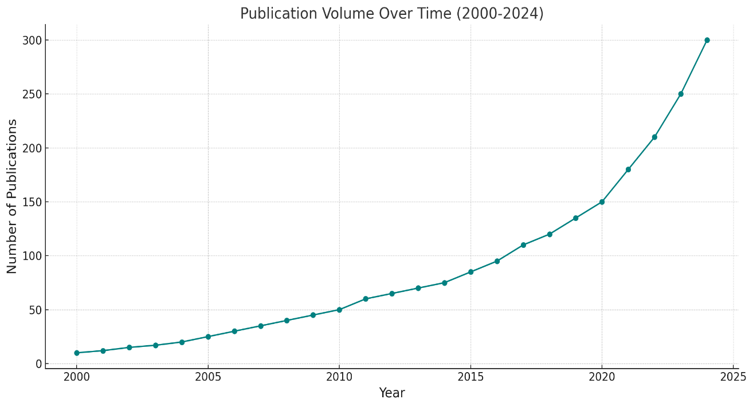

Figure 1: Line chart showing the growth in the volume of publications related to elderly care in China from 2000 to 2024

### 3.2 Core Literature and Knowledge Base

Co-citation analysis revealed a strong knowledge base on elderly care services in China. Foundational studies addressed socioeconomic factors, rural family care systems, and urban institutional care. Influential works, such as the '13th Five-Year Plan for Elderly Care Services,' highlighted the economic and policy disparities driving the urban-rural care divide, providing a theoretical foundation for future research.

However, much of the influential literature in rural contexts stressed the critical role of family networks in providing care, notably where government services were lacking. It also studied the psychological impact of the older adults left behind in rural areas where their families had gone to find jobs in urban centers (Qin, Wang, & Hsieh, 2018). On the other hand, urban research focused on efficient institutional nursing care homes and community-based centers. Here, these studies explored what urban systems could accomplish when advanced technologies were combined with healthcare services to suit better the needs of elderly residents in their urban environments. This study analyzed co-citation networks to identify these two research streams' integral role in shaping the field, indicating a requirement for a holistic approach that addresses urban and rural disparity. In addition, recurring themes of inequity in policy support and resource allocation were highlighted from the knowledge base. Implementation failures were often identified as having led rural elderly care studies to point to policies developed at the national level, which were challenged by localized situations, as failing to achieve outcomes. Meanwhile, urban studies focused on improving efficiency and accessibility in well-funded systems.

### 3.3 Keyword Co-occurrence and Hotspot Clusters

Keyword co-occurrence analysis reveals key research hotspots in elderly care. Terms like 'family support,' 'social security,' and 'elderly poverty' dominate rural studies, highlighting reliance on family networks and the need for stronger social safety nets. These keywords underscore the economic vulnerability of rural elderly populations and the critical role of community-based interventions in addressing their challenges.

Instead, urban-oriented research had keywords such as "community care," "institutional care," and "smart elderly care." Such terms reflect the wide variety of service models used in urban regions, where institutional and technology-driven solutions are responsible for a growing share of that demand. In that domain, studies often focused on integrating health care services with elderly care, piling it up with technology to increase efficiency and accessibility. As urban care challenges become increasingly important, the idea of "smart elderly care" using technology has become a hot spot of research, underscoring technology's role in resolving urban care issues.

Cluster analysis was used to identify thematic clusters, such as 'rural family support networks,' 'urban institutional efficiency,' and 'integrated medical and elderly care policies.' Where does the research stand regarding elderly care, and what are the priorities and challenges in these different contexts? Simplistically, these clusters present a nuanced image of the landscape of research. Therefore, for example, urban clusters focused on service delivery and technology optimization, while rural clusters emphasized policy and community support. Such differences highlight the need for context-specific approaches to address elderly care disparities.

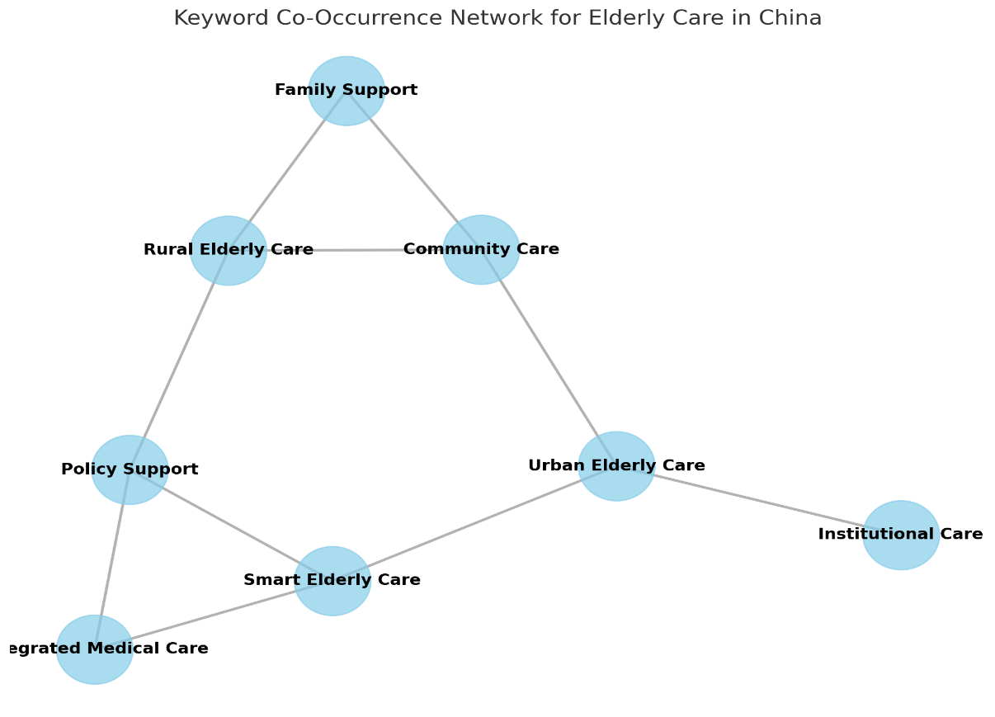

Figure 2: Keyword Co-Occurrence Network for elderly care research in China network diagram

### 3.4 Thematic Evolution and Emerging Trends

Burst detection analysis revealed thematic shifts in elderly care research across three periods. From 2000 to 2010, research focused on infrastructure development and the decline of family-based care in rural areas, highlighting the need for improved healthcare systems. Between 2010 and 2020, the focus shifted to integrated care models and community-based services, driven by significant policy advances, including medical-elderly care integration (Yuan et al., 2024). Researchers, especially in urban areas, increasingly emphasize the need for collaboration between healthcare providers and elderly care services. A key theme was the development of community care, which went some way toward decentralizing services and increasing their proximity to elderly audiences. For example, the last period (from 2020 to the present) has witnessed a rise in innovative elderly care technologies. Moreover, terms like "IoT," "big data," and "smart care systems" abound, reflecting the ballooning interest in technology-based solutions. As presented here, innovations have great potential for tackling the problems of elderly care in cities where infrastructure and resources are available easily (Fu et al., 2021). However, they present a critical gap that requires further attention, as adoption in rural contexts is limited.

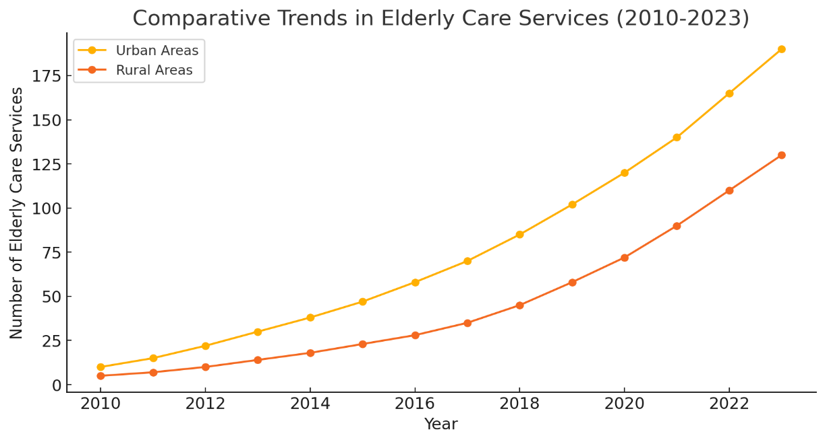

Figure 3: Comparative Line Chart for Elderly Care Services showing trends for urban and rural areas.

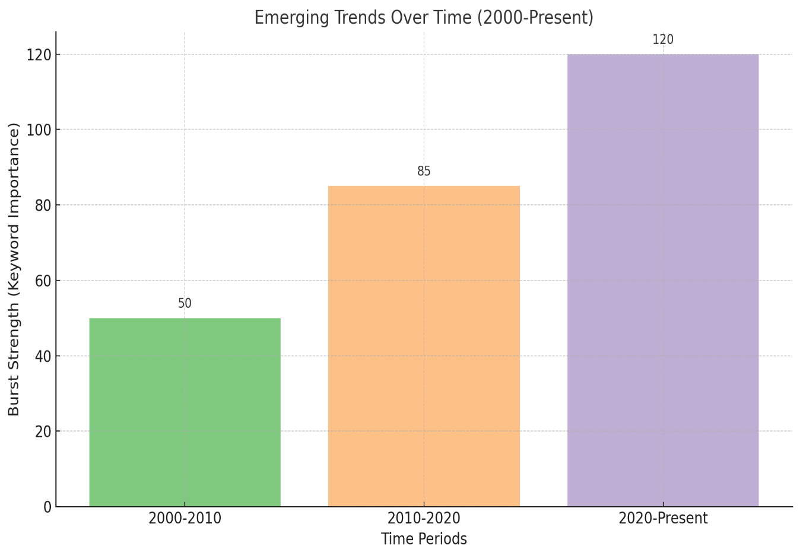

Figure 4: Emerging Trends

Data:

2000-2010: Family-Based Care (Burst Strength = 50)

2010-2020: Integrated Care Models (Burst Strength = 85)

2020-Present: Smart Elderly Care (Burst Strength = 120)

### 3.5 Theoretical Framework: A Unified Approach to Understanding Urban-Rural Elderly Care Disparities

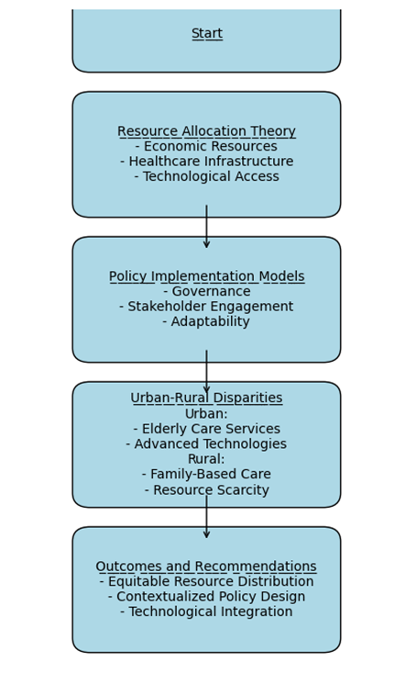

Figure 5: Theoretical Framework

By integrating Resource Allocation Theory and Policy Implementation Models, this study examines how resource concentration and implementation barriers exacerbate urban-rural disparities. Centralized policies often neglect local needs in underfunded rural areas, while urban regions benefit from stronger governance and institutional care systems. This imbalance creates a feedback loop of systemic disparities, where inadequate policy adaptation perpetuates resource inequalities. The integrated framework explains disparities and offers actionable insights for policy reform in aging societies. Urban areas benefit from concentrated resources, enabling investments in facilities, skilled personnel, and advanced technologies (Zhang et al., 2021). In contrast, rural areas face underdevelopment, resource shortages, and reliance on informal caregivers (Warner, 2020). These imbalances perpetuate inequalities, leaving rural elderly populations increasingly disadvantaged.

Policy Implementation Models reveal the disconnect between central policy design and local execution, identifying barriers such as inadequate stakeholder engagement, insufficient local governance structures, and the mismatch between national priorities and regional realities (Yip et al., 2019). It is understood that cities benefit from central policies backed by sound governance and infrastructure. On the other hand, regional issues are pointed out inappropriately due to a lack of effectiveness due to the misfit of the given policy with the regional framework (Liu et al., 2020). First, decision-makers at the center pay little attention to input from stakeholders in formulating rural policies, hence coming up with measures that do not effectively solve local problems (Yip et al., 2019). Lack of governance structures and ineffective scrutiny also negatively affect policy results in rural contexts, compared with better-organized environments and more structured and effective systems in the urban context.By integrating these models, this study demonstrates that urban regions benefit from robust governance frameworks and resource availability, allowing for effective policy enactment. In contrast, rural areas often experience policy misalignment due to limited administrative capacity and the absence of context-specific adaptations, exacerbating disparities in care quality and access.

This study highlights the interdependence of resource distribution and policy implementation in shaping elderly care outcomes. Reducing disparities requires greater investment in rural healthcare infrastructure and enhanced inclusion of rural populations in policymaking (Li et al., 2018). Strengthening monitoring and evaluation capacities in remote regions can also reduce policy failures caused by inefficiency and ineffectiveness. This integrated framework elucidates how resource concentration and implementation barriers deepen the urban-rural divide. It advocates for targeted interventions, such as increasing rural healthcare investments, tailoring policies to regional needs, and strengthening local governance to ensure policy effectiveness.

### Elderly Care Services: Types of Services Delivered

Elderly care services vary significantly between urban and rural areas, shaped by resource availability, infrastructure, and policy implementation. In urban regions, institutional care services such as nursing homes, rehabilitation centers, and long-term care facilities are well-funded and equipped with advanced medical technologies. These facilities are staffed with qualified medical professionals and offer specialized programs tailored to the diverse needs of the elderly. In contrast, rural areas face significant challenges, with limited institutional care facilities that often lack sufficient resources and qualified staff.

Community-based services in urban areas are more structured, providing daycare centers, home healthcare services, mental health support, and recreational activities to enhance social well-being. However, in rural areas, such services are less formalized and often depend on local NGOs or religious institutions. Informal care also plays a critical role, with urban areas supplementing family caregiving with paid caregivers or private agencies. In rural areas, caregiving relies almost entirely on family members, placing substantial burdens on informal caregivers, particularly women.

Technology highlights a stark urban-rural divide. Urban elderly access telemedicine, health apps, and AI-driven monitoring tools, while rural areas face limited access due to poor internet connectivity and low awareness. These disparities highlight the need for tailored interventions to bridge the gap in elderly care services across urban and rural settings.

### Comparative Table of Urban and Rural Elderly Services

|  |  |  |
| --- | --- | --- |
| **Category** | **Urban Elderly Services** | **Rural Elderly Services** |
| **Institutional Care** | Well-funded, technology-enhanced nursing homes and hospitals; specialized geriatric care. | Limited facilities, minimal technology, and fewer specialized caregivers. |
| **Community-Based Care** | Structured programs: daycare, recreational, mental health support. | Informal networks, sporadic NGO involvement; limited organized programs. |
| **Accessibility** | Close proximity to services, public transport availability. | Geographic isolation, lack of transport infrastructure. |
| **Technology Utilization** | Advanced tools: telemedicine, health tracking apps, AI diagnostics. | Low adoption due to poor internet connectivity and lack of awareness. |
| **Caregiver Availability** | Professional caregivers supported by family and private agencies. | Family-dependent care with minimal professional support. |

**Factors Influencing Elderly Care Services**

Insights from CiteSpace’s bibliometric analysis reveal key factors influencing elderly care services. One critical factor is resource allocation. Urban areas benefit from higher resource prioritization due to stronger economic development, better governance frameworks, and superior infrastructure. In rural regions, chronic underinvestment, limited budgets, and poor resource utilization result in significant service gaps (Zhang et al., 2021). Policy implementation barriers further exacerbate disparities. Centralized policies often fail to adapt to the unique needs of rural areas, resulting in a misalignment between national priorities and local realities. Rural policies are often developed without adequate stakeholder engagement, leading to ineffective solutions (Yip et al., 2019). Urban areas, on the other hand, benefit from robust governance and infrastructure, which support the effective enactment of policies.

Demographic trends also play a significant role. Urban areas experience a growing elderly population as younger generations migrate in search of better opportunities and healthcare access. In rural areas, migration creates "empty nest" households where elderly individuals are left without sufficient support (Liang et al., 2018). Furthermore, rural areas struggle to attract healthcare professionals, leading to staff shortages and inadequate specialized training programs (Warner, 2020). Technology adoption highlights another disparity. Urban centers leverage advanced health technologies such as telemedicine and AI-driven diagnostics, while rural areas lag due to limited internet penetration and technological infrastructure (Li et al., 2018). Cultural factors further contribute to the divide, as traditional caregiving models, such as filial piety, are eroding in rural areas due to urban migration and changing family structures (Xing et al., 2018).

## Discussion

### 4.1 Major Differences in Urban and Rural Elderly Care Services

The findings of this analysis showed appreciable differences in factors that influence the supply of elderly care services in urban and rural areas. Compared with other parts of the country, in terms of resource allocation, metropolitan areas have more abundant medical and elderly care facilities, with more economic investment and more developed infrastructure (Shi et al., 2023). Thus, these advantages allow urban regions to provide services from institutional care to community-based programs to advanced technological solutions (Feng et al., 2020). However, rural areas are characterized by resource shortages, mainly a lack of healthcare facilities and poor infrastructure. Rural elderly persons often depend on family support, a model that has become increasingly unsustainable as rural areas lose population to urban centers (Han et al., 2020). Also, service models greatly vary from place to place (rural or urban).

Zhao et al. (2020) suggested that economic development shows a concentrated distribution of resources for infrastructure investment and health sector development due to the density of urban areas. They usually provide the best clinical diagnostic centers, modern concept senior living homes, telemedicine, personal health care machines, etc. This availability means that urban consumers have choices from total dependency, which one may seek in a nursing home, to limited facility-dependent programs available on a community basis for fractional need types. On the other hand, rural centers are characterized by a chronic scarcity of resources that hinders the development of adequate protocols for elderly caregiving (Fang et al., 2020). As indicated earlier, most rural preparedness assessment indicators are poorly developed and lack adequate funding and human resources (Wang et al., 2021). This scarcity puts much pressure on older people in these regions, depending on family support, and gradually becomes a mirage due to rural depopulation. In most developing countries, the youth have been migrating to urban areas, which has resulted in an increasing number of old persons being left alone in rural areas; they can rarely afford even basic health facilities.

According to Resource Allocation Theory, urban areas thrive on concentrated resources and advanced technologies, while rural regions struggle to adapt centralized policies to local contexts, relying on traditional family-based care and irregular community support.Internationally, Japan’s integrated care systems and Scandinavia’s decentralized governance showcase effective approaches to urban-rural disparities, emphasizing localized policies and technology integration. These models leverage public-private partnerships and community engagement to ensure equitable resource distribution.

Rural elderly populations rely heavily on informal care networks, which often fail to meet their needs, increasing their vulnerability. While urban areas benefit from comprehensive policies and funding, rural implementation is hindered by resource shortages and governance gaps (Tang et al., 2021). National initiatives frequently overlook rural-specific challenges, resulting in uneven coverage and limited impact. These disparities underscore the need for targeted interventions tailored to the unique needs of rural communities.

Service models also show the divide between urban and rural. Urban areas utilize institutional and community care models, supported by professional caregiver training and integrated health and social care. These approaches enable elderly residents to access specialized services that improve their physical and mental health (Jia et al., 2021). On the other hand, most, if not all, of the rural nations continue to use the traditional family-based care system. - Unfortunately, this model based on cultural ideas of filial responsibility no longer suffices for families dealing with a lack of finances and a decreasing ability to care for older people. Substituting institutional care by attending relatives is less professional and less frequent than professional care agencies. This dependency poses a problem to the extent that the rights of rural elderly patients are vulnerable, and their needs are unrecognized.

### Theoretical and Practical Implications

This study contributes to both theory and practice by offering an integrated framework to explain the determinants of elderly care services in China. Combining co-citation analysis, keyword co-occurrence, and thematic evolution, the study examines the interplay of resources, service models, and policy support in shaping elderly care outcomes. This framework serves as a foundation for future research, encouraging scholars to explore broader perspectives on elderly care, including the impact of technology and intergenerational dynamics. The study provides a set of practical insights for policymakers and practitioners. The findings reveal the critical need for equitable resource distribution, particularly in rural areas where resource shortages are most significant. In addition, they specify the importance of uniting healthcare and elderly care services, a way of working that has worked well in cities. Moreover, the study corroborates those innovative technologies can tackle system problems with proper training and infrastructure development. The implications of such insights for designing and implementing elderly care policies and programs can help improve elderly care services in China.

Also, the theoretical framework presented offers a comprehensive perspective on the disparities in elderly care between urban and rural China, emphasizing the critical roles of resource allocation and policy implementation. It clearly highlights how the unequal distribution of resources exacerbates the divide in care quality, particularly in rural areas where underdevelopment persists. A number of systematic issues in rural areas make it almost impossible to deliver adequate care; urban areas, however, have the resources and organized administration. This is the cycle that not only makes the elders in rural regions receive poor services but they are placed even worse off than they used to be.

By integrating Resource Allocation Theory and Policy Implementation Models, this study demonstrates the interdependence of these factors in shaping elderly care outcomes. Resource disparities between urban and rural areas contribute to unequal service delivery, with rural regions receiving significantly fewer resources, but where policies are developed in centralized offices but implemented in rural areas, there is a disparity between the two. Hearths are born and nurtured well where policies are implemented; on the other hand, they falter in rural settings, where no concrete policies are implemented to meet the area's needs. The gaps above are further deepened by the scarcity of adequate local government and policy, even though they are often stronger in urban settings.

Based on these gaps, the study recommends that the elaboration of recommendations for improving rural healthcare facilities coupled with the increased participation of the rural population in decision-making processes is required. This would help improve resources, facilities, and staff for the countryside so that the countryside has access to the same quality of carers as the city. Further, improving the monitoring and evaluation processes can eliminate policy breakdowns in these areas, implying that improvements in intervention can be made locally. Top of FormBottom of Form

### 4.3. Limitations

This study has limitations, including reliance on English and Chinese databases, which may exclude relevant research from other languages and contexts. Additionally, bibliometric methods may miss qualitative insights, such as cultural influences on elderly care practices, highlighting the need for mixed-methods approaches in future research. Additionally, bibliometric methods rely on existing keywords, which may overlook emerging but less established themes in elderly care research. Future research should employ mixed methods, integrating qualitative interviews and quantitative modeling, to capture the nuanced experiences of caregivers and elderly individuals while quantifying the impact of policy interventions on care outcomes. This would provide a richer understanding of the socio-cultural and institutional dynamics influencing elderly care services. Longitudinal studies are essential to assess the long-term impacts of policies and interventions on elderly care. Such research could explore how demographic shifts, technology adoption, and policy adjustments shape the urban-rural divide over time. Additionally, cross-cultural comparative studies could identify adaptable best practices from other aging societies, such as Japan or Sweden, to inform China's elderly care strategies.This may lead to only getting part way to grasping trends and practices of elderly care in the global arena. Second, reliance on keyword-based clustering may overlook emerging themes or interdisciplinary perspectives not yet well-represented in existing literature, potentially narrowing the scope of identified research gaps. From this limitation, it is pretty clear that quantitative research should be accompanied by other qualitative techniques, including content analysis or expert interviews, to deepen the understanding of the key drivers of elderly care services. Finally, this study focuses on resource allocation and policy implementation at a macro level, without examining micro-level factors such as individual caregiver experiences or specific institutional practices. This limits the understanding of how systemic disparities manifest in everyday care delivery.However, these limitations should not be taken to mean that the study lacks sufficient evidence for tackling urban/rural differences in elderly care or that the framework presented here lacks clear directions for follow-up investigation and policymaking. Following the understanding of structural, cultural, and economic barriers, China could attempt to construct a fair and sustainable elderly care system for the society bearing the growing population of seniors.

## Conclusions and Recommendations

### **5.1 Key Findings**

This study underscores stark disparities in elderly care between urban and rural China. Urban areas leverage advanced infrastructure, economic resources, and technology to provide diverse care models, while rural regions suffer from underfunding, inadequate infrastructure, and weak policy implementation, worsened by youth migration. Addressing these challenges requires equitable resource allocation and tailored interventions to bridge the urban-rural divide.

The findings of this study also provide empirical evidence documenting the urban-rural division of elderly care services in China and the expansion of this gap in subsequent years; the finding suggests the imperative of solving the problem through system reform. A strong infrastructure, improved access to economic resources, and comprehensive policies enable the provision of enhanced models of care in urban sectors. These include programs such as institutional and community-based care programs; these programs are usually backed with newer technologies such as telemedicine and data health management systems. Together, the three aid in bringing distinction in care that, therefore, meets the different needs of the aging population within the urban setting. Also, the intensity of elderly care is high in urban areas, and the health workers in the area are well-trained to handle the situation.

On the other hand, the rural sector remains stagnant in development, with a poor cash base and poor health facilities. As such, the issue of policy implementation refers to the inability to actualize such policies, which in any case isn't easy, and when harnessed to the challenges above, it makes the going even more challenging. This is because youths are moving en masse to urban centers in search of better job opportunities, leaving our rural counterparts with a scarcity of caregivers and health professionals. This has led to an overreliance on family care systems, which are now locked into the culture of the society but which offered little above basic care to older people. Hence, rural older adults have almost extremely restricted opportunities to get quality care, which has an adverse effect on the health status of elderly persons and makes them more vulnerable.

### Policy Recommendations

A bibliometric analysis suggests key policy measures to narrow urban-rural disparities in elderly care services. ridging disparities demands investments in rural healthcare infrastructure and capacity-building, including caregiver training centers and subsidized telehealth services. Specifically, the government should:

1. provide grants to equip rural facilities with telemedicine devices and wearable health monitors.
2. Establish targeted training programs for family caregivers, focusing on basic medical care and the use of new technologies.
3. Develop partnerships with private sectors and NGOs to create sustainable community-based programs that supplement family care networks.
4. Introduce financial incentives, such as tax breaks, for companies investing in elderly care infrastructure in rural areas.

However, adopting such innovative technologies as IoT and wearable devices has the potential to boost care quality, and financial incentives and training programs should be implemented to encourage technology uptake into these areas, particularly in rural areas where technology uptake is lagging. To this end, we need strong monitoring mechanisms to ensure national policies are adjusted and executed for local contexts. Public-private partnerships can also scale successfully integrated models of care across rural and urban regions, and they can leverage ‘technological expertise’ to fill service gaps and work with NGOs and private sector stakeholders as part of partnerships.

Also, Exclusive grants and subsidies should be provided to rural clinics for acquiring new technologies. These funds can support purchasing devices, training healthcare professionals, and establishing local technological infrastructure. Rural civil society programs should foster collaboration among local governments, NGOs, and businesses. Such platforms could establish volunteer-based caregiver organizations, particularly in areas with limited family caregiver support. In addition, incentives and bargaining that focus on investment in necessary technologies within eldercare, such as tax exemptions or subsidies for families and businesses in rural areas, should be introduced. Lastly, this plan must be supported by strong monitoring and evaluation frameworks that would allow for the evaluation of the impact of interventions and feedback on the policymaking process.

### Future Research Directions

Future research should integrate sociology, economics, and technology to create sustainable care models. Longitudinal studies can evaluate policy impacts over time, while cross-cultural comparisons may highlight best practices from other aging societies to address China’s urban-rural disparities. More research is also needed on innovative technologies' impact on care quality and accessibility, particularly in rural areas where adoption lags. Finally, studies focused on equity in policy implementation are crucial for ensuring effective care delivery across all geographic locations, including examining governance structures and community engagement approaches to address persistent urban-rural disparities in elderly care services.

## References

Bao, J., Zhou, L., Liu, G., Tang, J., Lu, X., Cheng, C., ... & Bai, J. (2022). The current state of care for older people in China in the context of an aging population. *Bioscience Trends, 16*(2), 107-118.

Chen, X., Giles, J., Yao, Y., Yip, W., Meng, Q., Berkman, L., ... & Zhao, Y. (2022). The path to healthy aging in China: a Peking University–Lancet Commission. The Lancet, 400(10367), 1967-2006.

Eggleston, K. (2020). Demographic and health care challenges. *Fateful Decisions*, pp. 151–179.[https://www.degruyter.com/document/doi/](https://www.degruyter.com/document/doi/10.1515/9781503612235-010/pdf?licenseType=restricted)

Fang, E. F., Xie, C., Schenkel, J. A., Wu, C., Long, Q., Cui, H., ... & Woo, J. (2020). A research agenda for aging in China in the 21st century: Focusing on basic and translational research, long-term care, policy and social networks. Aging research reviews, 64, 101174.

Feng, Z., Glinskaya, E., Chen, H., Gong, S., Qiu, Y., Xu, J., & Yip, W. (2020). Long-term care system for older adults in China: Policy landscape, challenges, and prospects. *The Lancet, 396*(10259), 1362-1372.

Fu, Y., Lin, W., Yang, Y., Du, R., & Gao, D. (2021). Analysis of diverse factors influencing the health status as well as medical and health service utilization in the floating elderly of China. BMC Health Services Research, 21(1), 438.

Guo, Y., & Wang, J. (2024). Practices for rural population aging in China: Land-based pension. *Habitat International*, *151*, 103136.<https://www.sciencedirect.com/science/article/pii/S019739752400136X>

Han, Y., He, Y., Lyu, J., Yu, C., Bian, M., & Lee, L. (2020). Aging in China: Perspectives on public health. *Global Health Journal*, *4*(1), 11-17.

Jiang, H., Xiao, S., Hu, H., & He, H. (2022). Study the measurement and influencing factors of care service demand of disabled elderly in urban and rural China. *International Journal of Environmental Research and Public Health, 19*(17), 11112.

Jia, X., Wang, Z., Huang, F., Su, C., Du, W., Jiang, H., ... & Zhang, B. (2021). A comparison of the Mini-Mental State Examination (MMSE) with the Montreal Cognitive Assessment (MoCA) for mild cognitive impairment screening in Chinese middle-aged and older population: a cross-sectional study. BMC Psychiatry, 21, 1-13.

Liang, D., Mays, V. M., & Hwang, W. C. (2018). Integrated mental health services in China: challenges and planning for the future. Health policy and planning, 33(1), 107-122.

Li, J., Shi, L., Liang, H., Ding, G., & Xu, L. (2018). Urban-rural disparities in health care utilization among Chinese adults from 1993 to 2011. *BMC Health Services Research, 18*, 1-9.

Li, Y., Wang, L. E., Liu, G., & Cheng, S. (2021). Rural household food waste characteristics and driving factors in China. Resources, Conservation and Recycling, 164, 105209.

Liu, L., Xue, P., Li, S. X., Zhang, J., Zhou, J., & Zhang, W. (2020). Urban-rural disparities in mental health problems related to COVID-19 in China. General hospital psychiatry, 69, 119.

Qin, X., Wang, S., & Hsieh, C. R. (2018). The prevalence of depression and depressive symptoms among adults in China: estimation based on a National Household Survey. China Economic Review, 51, 271-282.

Shi, Y., Ma, D., Zhang, J., & Chen, B. (2023). In the digital age: a systematic literature review of the e-health literacy and influencing factors among Chinese older adults. Journal of Public Health, 31(5), 679-687

Sun, X., Zhen, X., Hu, X., Li, Y., Gu, S., Gu, Y., & Dong, H. (2019). Osteoarthritis in the middle-aged and elderly in China: prevalence and influencing factors. International Journal of Environmental Research and Public Health, 16(23), 4701.

Tang, T., Jiang, J., & Tang, X. (2021). Prevalence of depressive symptoms among older adults in mainland China: a systematic review and meta-analysis. Journal of Affective Disorders, 293, 379-390.

Wang, L., Wang, Z., Ma, Q., Fang, G., & Yang, J. (2019). The development and reform of public health in China from 1949 to 2019. *Globalization and Health, 15*, 1-21.

Wang, L., Zhou, B., Zhao, Z., Yang, L., Zhang, M., Jiang, Y., ... & Li, X. (2021). Body-mass index and obesity in urban and rural China: findings from consecutive nationally representative surveys during 2004–18. The Lancet, 398(10294), 53-63.

Xing, Y., Pei, R., Qu, J., Wang, J., Zhou, H., Wang, Z., ... & Li, L. (2018). Urban-rural differences in factors associated with willingness to receive eldercare among older people: A cross-sectional survey in China. *BMJ Open, 8*(5), e020225.

Yuan, L., Xu, Q., Gui, J., Liu, Y., Lin, F., Zhao, Z., & Sun, J. (2024). Decomposition and comparative analysis of differences in depressive symptoms between urban and rural older adults: evidence from a national survey. International psychogeriatrics, 36(7), 587-598.

Yue, S., Zhang, J., Cao, M., & Chen, B. (2021). Knowledge, attitudes and practices of COVID-19 among urban and rural residents in China: a cross-sectional study. Journal of Community Health, 46, 286-291.

Zhang, L., Zeng, Y., Wang, L., & Fang, Y. (2020). Urban-rural differences in long-term care service status and needs among home-based older adults in China. *International Journal of Environmental Research and Public Health, 17*(5), 1701.

Zhang, W., Zhang, X., & Wu, G. (2021). The network governance of urban renewal: A comparative analysis of two cities in China. Land Use Policy, 106, 105448.

Zhao, Y., Atun, R., Oldenburg, B., McPake, B., Tang, S., Mercer, S. W., ... & Lee, J. T. (2020). Physical multimorbidity, health service use, and catastrophic health expenditure by socioeconomic groups in China: an analysis of population-based panel data. The Lancet Global Health, 8(6), e840-e849.

Zou, X., Fitzgerald, R., & Nie, J. B. (2020). “Unworthy of Care and Treatment”: Cultural Devaluation and Structural Constraints to Healthcare-Seeking for Older People in Rural China. International journal of environmental research and public health, 17(6), 2132.<https://www.mdpi.com/1660-4601/17/6/2132>

Zhou, Y., Wushouer, H., Vuillermin, D., Ni, B., Guan, X., & Shi, L. (2020). Medical insurance and healthcare utilization among the middle-aged and elderly in China: evidence from the China health and retirement longitudinal study 2011, 2013 and 2015. BMC health services research, 20, 1-9.